Topic: Digital Loan Origination and Credit Risk Assessment Platform

- Understand the Problem Statement
Problem Explanation
A Digital Loan Origination and Credit Risk Assessment Platform is a software system that automates the entire loan lifecycle—from customer registration and loan application to document verification, credit risk analysis, loan approval, and repayment tracking.
In many banks, loan processing is still manual or semi-digital, requiring customers to visit branches, submit paper documents, and wait several days or weeks for approval. This process is slow, expensive, and prone to human errors and fraud.
The proposed platform digitizes the entire process using modern software technologies, enabling faster approvals, accurate credit assessment, and improved customer satisfaction.

Objectives
- Automate the loan application process.
- Reduce loan approval time.
- Improve credit risk assessment accuracy.
- Minimize fraud and manual errors.
- Provide secure online services.
- Improve customer satisfaction.
- Reduce operational costs.
- Ensure regulatory compliance.

Scope
The system includes:
- Customer Registration
- Login & Authentication
- Online Loan Application
- Document Upload
- Digital KYC Verification
- Credit Score Evaluation
- Risk Assessment
- Loan Approval/Rejection
- EMI Calculation
- Loan Tracking
- Notifications (SMS & Email)
- Reports & Analytics
- Admin Dashboard

- Identify Key Stakeholders and Challenge
Stakeholder | Roles & Responsibilities | Challenges
Customer | Register, apply for loans, upload documents, track application | Long approval time, paperwork, lack of transparency
Loan Officer | Verify documents, review applications, approve/reject loans | Heavy workload, manual verification
Credit Analyst | Evaluate credit score and financial risk | Fraud detection, accurate prediction
Bank Manager | Monitor loan performance and policies | Managing default risk, ensuring compliance
System Administrator | Maintain software, database, and security | Data security, system downtime
Credit Bureau | Provide customer credit history | Accurate and timely credit information
Major Challenges
- Manual document verification
- Human errors
- Loan fraud
- Slow approval process
- High operational cost
- Inconsistent loan decisions
- Data security threats
3. Analyze the Current Approach
Existing System
Most financial institutions use:
- Paper-based applications
- Manual KYC verification
- Manual credit checking
- Physical branch visits
- Manual approval process

Strengths
- Human judgment in complex cases
- Established banking procedures
- Personal customer interaction
Limitations
- Slow processing
- Paperwork
- High operational costs
- Human errors
- Fraud risk
- Poor customer experience
Problems/Gaps
- Delayed approvals
- Duplicate documentation
- Lack of automation
- Limited transparency
- Inconsistent credit decisions
- Difficulty handling large numbers of applications
4. Proposed Software Solution Using Software Engineering Principles
Proposed System
- The proposed platform automates the complete loan process through secure web and mobile applications.
System Workflow
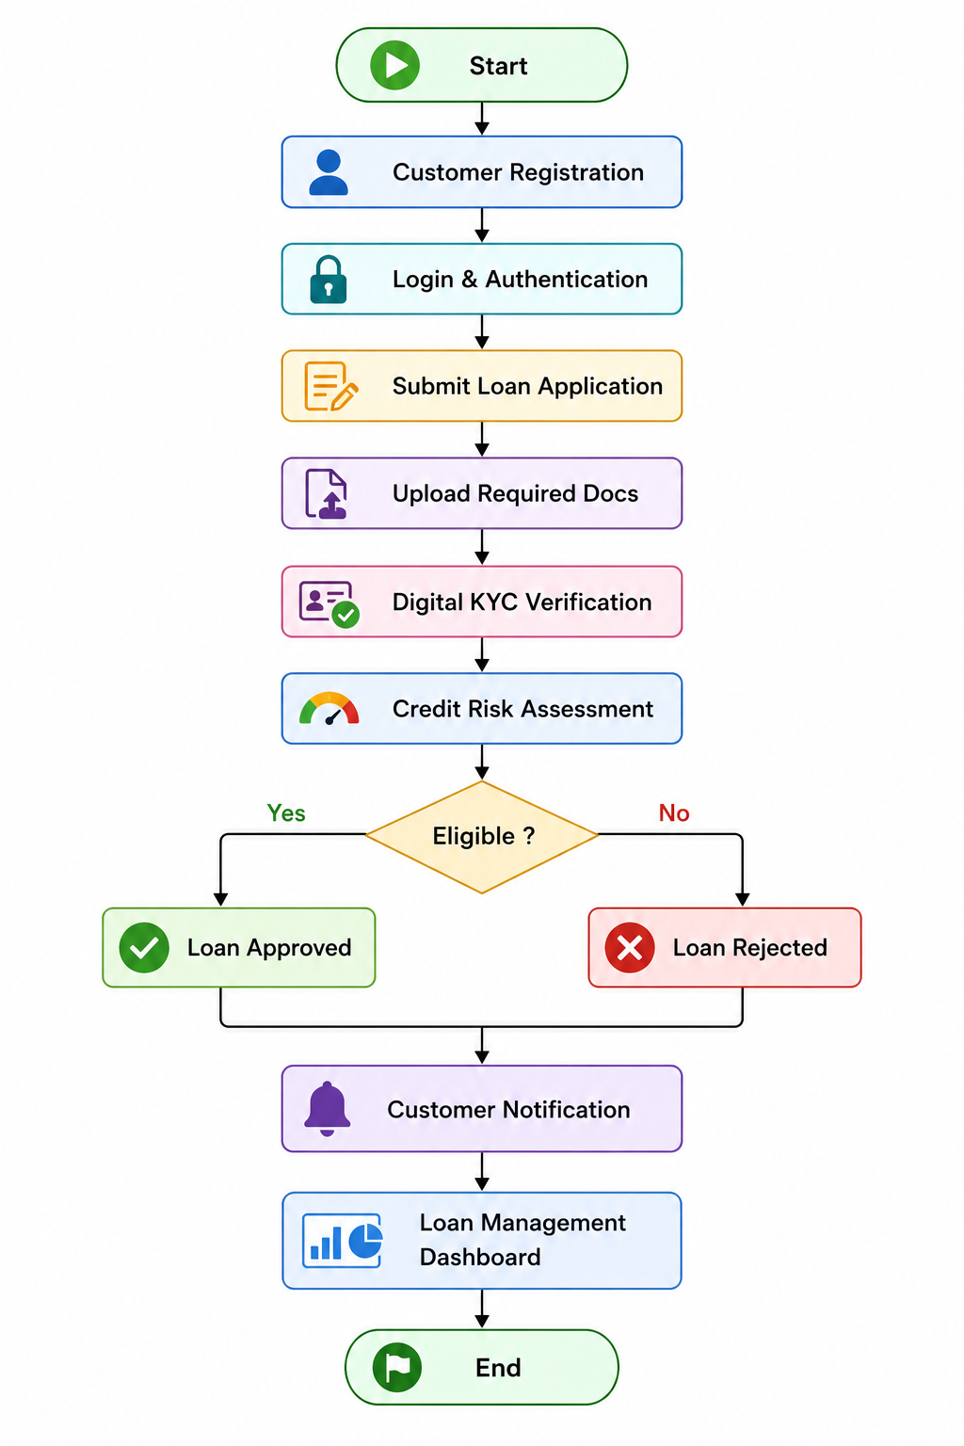
Functional Modules
Module 1 – User Registration & Login
Functions:
- User registration
- Login
- Password reset
- OTP verification

Module 2 – Loan Application
Functions:
- Apply for loan
- Select loan type
- Enter personal and financial details
- Upload supporting documents

Module 3 – Document Verification
Functions:
- Aadhaar verification
- PAN verification
- Income proof validation
- OCR-based document scanning

Module 4 – Credit Risk Assessment
Functions:
- Credit score calculation
- Income analysis
- Debt-to-income ratio analysis
- Risk classification
- Eligibility prediction

Module 5 – Loan Decision Engine
Functions:
- Automatic approval
- Automatic rejection
- Loan amount recommendation
- Interest calculation

Module 6 – Notification System
Functions:
- SMS alerts
- Email notifications
- Application status updates

Module 7 – Admin Dashboard
Functions:
- User management
- Loan monitoring
- Report generation
- Analytics
- Audit logs

Functional Requirements
- User registration
- Secure login
- Loan application
- Document upload
- KYC verification
- Credit score calculation
- Loan approval/rejection
- EMI calculator
- Loan tracking
- Notification service
- Reports

Non-Functional Requirements
Security
- Data encryption
- OTP authentication
- Multi-factor authentication
- Secure database

Reliability
- 99.9% uptime
- Automatic backup

Scalability
- Support millions of users
- Cloud deployment

Performance
- Fast response time
- Quick processing

Maintainability
- Modular software architecture
- Easy updates

Usability
- User-friendly interface
- Mobile responsive
Availability
- 24×7 service

Software Engineering Principles
Modularity
- Each function (Login, Loan, Credit Assessment, Reports) is developed as an independent module.
Scalability
- Supports increasing users without reducing performance.
Maintainability
- Easy to update and fix bugs.
Reliability
- Ensures accurate loan processing.
Usability
Simple and intuitive interface.
Security
- Protects sensitive financial data through encryption, secure authentication, and access control.

5. Justify the Chosen Methodology / Framework
Selected SDLC Model
Agile Scrum

Why Agile Scrum?
- Requirements change frequently in banking systems.
- Delivers software in small, manageable sprints.
- Encourages continuous customer feedback.
- Faster bug fixing and testing.
- Improves collaboration among developers and stakeholders.
- Supports continuous improvement and maintenance.

Scrum Roles
- Product Owner
- Scrum Master
- Development Team
- Testing Team

Scrum Artifacts
- Product Backlog
- Sprint Backlog
- Product Increment

Scrum Events
- Sprint Planning
- Daily Scrum
- Sprint Review
- Sprint Retrospective

Why Agile is Suitable
- Faster software delivery
- Better quality
- Reduced project risk
- Continuous maintenance
- Customer satisfaction
- Easy feature enhancements

6. Discuss Expected Outcomes and Limitations

Expected Benefits
- Faster loan approval
- Reduced paperwork
- Lower operational costs
- Improved customer experience
- Better credit risk prediction
- Reduced fraud
- Increased transparency
- Higher productivity
- Better regulatory compliance

How the Solution Addresses Challenges
- Automates document verification.
- Uses credit scoring for accurate decisions.
- Reduces manual work.
- Speeds up loan processing.
- Enhances security with authentication and encryption.
- Provides real-time application tracking.

Risks
- Cybersecurity attacks
- Data breaches
- Internet dependency
- Integration with existing banking systems
- Incorrect customer information

Limitations
- High initial development cost
- Employee training required
- Dependence on third-party credit bureaus
- Regular software maintenance
- Regulatory changes

Future Enhancements
- AI-based credit scoring
- Machine learning for fraud detection
- Blockchain for secure document verification
- Biometric authentication (Face/Fingerprint)
- Chatbot-based customer support
- Mobile banking integration
- Voice-enabled loan applications
- Predictive analytics for loan defaults
- Cloud-based scalability
- Real-time financial dashboards

Conclusion
The Digital Loan Origination and Credit Risk Assessment Platform modernizes traditional loan processing by automating customer registration, document verification, credit risk analysis, and loan approval. By applying Software Engineering principles such as modularity, scalability, reliability, maintainability, usability, and security, and adopting the Agile Scrum methodology, the system delivers faster, more accurate, secure, and customer-friendly loan services. This solution reduces processing time, minimizes fraud, improves decision-making, and enhances overall banking efficiency, making it an ideal solution for modern financial institution.

